13.1.8 Editors - Video Sequence Editor - Header - Strip Menu
Strip menu 2
Transform 3
Move 3
Last operator Sequence Slide 3
Offset X 3
Y 3
Move/Extend from Frame 3
Last operator Transform 3
Values X, Y, Z, W 3
Axis 3
Orientation 3
Proportional editing 3
Slip strip content 3
Swap Strip Left 3
Swap Strip Right 3
Remove Gaps 4
Last operator Remove Gaps 4
All Gaps 4
Insert Gaps 4
Last operator Remove Gaps 4
Frames 4
Split 4
Last operator Split Strips 4
Frame 4
Channel 4
Type 4
Use Cursor Position 4
Side 4
Hold Split 5
Last operator Split Strips 5
Frame 5
Channel 5
Type 5
Use Cursor Position 5
Side 5
Copy 5
Paste 5
Duplicate Strips 5
Last operator Duplicate Strips 5
Offset X 5
Y 5
Delete 6
Add Strip Modifier 6
Copy modifiers to selected strips 6
Effect Strip 6
Change Effect Input 6
Change Effect Type 6
Last operator Change Effect Type 7
Type 7
Reassign Inputs 7
Swap Inputs 7
Movie Strip 7
Set Render Size 7
Deinterlace Movies 7
Set Render Size 7
Separate Images 7
Last Operator Separate Images 7
Make Meta Strip 7
UnMeta Strip 8
Toggle Meta 8
Lock/Mute 8
Lock Strips 8
Unlock Strips 8
Mute Strips 8
Last operator Mute Strips 8
Unselected 8
Unmute Strips 8
Last operator Unmute Strips 8
Unselected 8
Mute unselected strips 9
Last operator Mute Strips 9
Unselected 9
Unmute deselected Strips 9
Last operator Unmute Strips 9
Unselected 9
Inputs 9
Reload Strips 9
Reload Strips and Adjust Length 9
Change Paths/Files 9
Swap Data 9

Strip menu
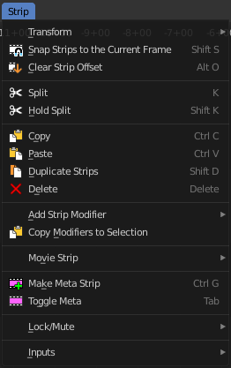
The strip menu contains strip related functionality.

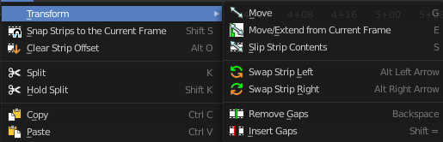
Transform

Move
Moves the selected strip(s).

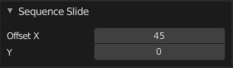
Last operator Sequence Slide

Offset X
The horizontal frame offset from the starting position.

Y
The vertical offset from the starting channel.

Move/Extend from Frame
Extends the selected strips relative to the frame indicator and the mouse position. All selected strip handles to the mouse side of the current frame indicator will transform together.

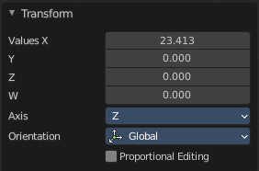
Last operator Transform

Values X, Y, Z, W
The transform values, relative to the starting point.

Axis
The transform axis orientation. This axis value box has no meaning here.

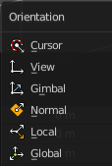
Orientation
Choose the type of orientation for the transform action.

Proportional editing
The tool has no proportional editing. The checkbox cannot be activated.

Slip strip content
Change the position of the contents of a strip without moving the strip itself.

Swap Strip Left
Swap the active strip with the strip to the left.

Swap Strip Right
Swap the active strip with the strip to the right.

Remove Gaps
Removes gaps at the frame indicator position in the current channel. Strips after the indicator will move to the left to close the gap.

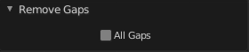
Last operator Remove Gaps

All Gaps
Remove all gaps between all clips at the right side.

Insert Gaps
Inserts a gap at the frame indicator position. Strips after the indicator will move to the right by the amount of gap frames.

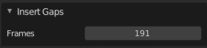
Last operator Remove Gaps

Frames
The size of the gap in frames.

Split
Split the selected strip into two parts at the current frame.

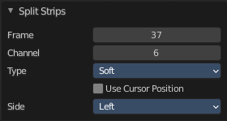
Last operator Split Strips

Frame
The frame at which the cut happens.

Channel
The channel of the strip.

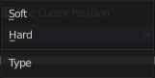
Type
How to cut. Soft or hard.

Use Cursor Position
Split at the position of the cursor instead of the current frame. Note! This setting makes no sense. You can't adjust the cursor position afterwards.

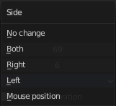
Side
The side that remains selected after the split.

Hold Split
Like Split, it splits a strip in two strips. But you will not be able to drag the endpoints to show the frames past the split of each resulting strip. You can adjust the Hold Offset number fields in the Strip Info panel.

Last operator Split Strips

Frame
The frame at which the cut happens.

Channel
The channel of the strip.

Type
How to cut. Soft or hard.

Use Cursor Position
Split at the position of the cursor instead of the current frame. Note! This setting makes no sense. You can't adjust the cursor position afterwards.

Side
The side that remains selected after the split.

Copy
Copies the selected strip(s).

Paste
Pastes copied strip(s).

Duplicate Strips
Duplicates the selected strip(s).

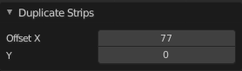
Last operator Duplicate Strips

Offset X
The horizontal frame offset from the starting position.

Y
The vertical offset from the starting channel.

Delete
Deletes the selected strip(s).

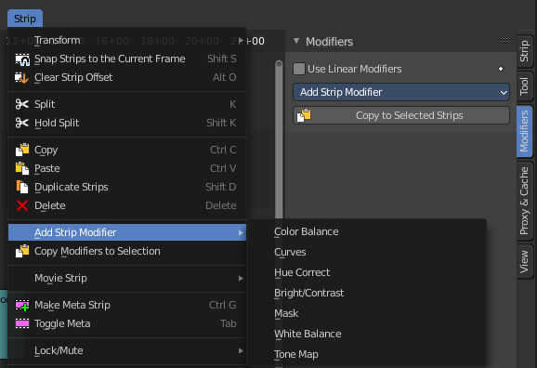
Add Strip Modifier
All strip types but Sound. Adds a strip modifier. Strip modifiers are explained in the sidebar chapters.

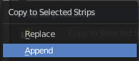
Copy modifiers to selected strips
Copies the modifiers from the source strip to the target strip by given method. It opens a popup where you can choose the method.
First select the source strip. Hold down shift, select the second strip. Perform the tool.

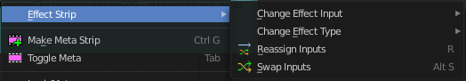
Effect Strip
Strip type Effect Strip.

Change Effect Input
Not documented by Blender. Not to figure out.

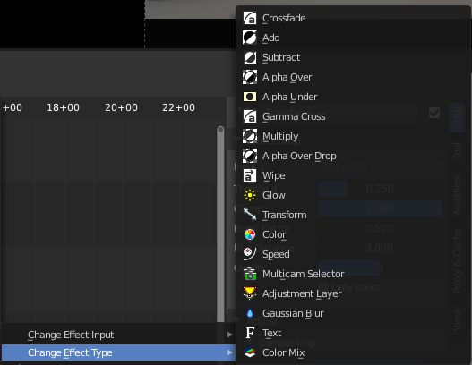
Change Effect Type
Change the effect type of the selected effect strip to the chosen method.

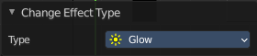
Last operator Change Effect Type

Type
The type of effect to change to.

Reassign Inputs
Reassigns the input for the effect strips.

Swap Inputs
Swap the first two inputs for the effect strip.

Movie Strip
Strip type Movie.

Set Render Size
Set the render size and aspect from the active strip. Attention, there is no feedback if the operation was successful. It simply sets it.

Deinterlace Movies
Deinterlaces the selected movie strips.

Set Render Size
Strip type Image. Set the render size and aspect from the active image strip. Attention, there is no feedback if the operation was successful. It simply sets it.

Separate Images
Strip type Image. Create a strip for every image in the image sequence strip.

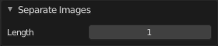
Last Operator Separate Images
The length of each frame of the new created strips.

Make Meta Strip
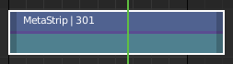
Creates a meta strip out of the selected strips. A Meta Strip is a strip which contain multiple strips treated as if it was one strip. It allows you to reduce the vertical space used in the Sequencer. You can edit it the same way as any other strips.
Note! The default blend mode for a Meta strip is Replace. There are many cases where this alters the results of the animation so be sure to check the results and adjust the blend mode if necessary.

UnMeta Strip
Separating (ungrouping) the Meta strip restores the strips to their relative positions and channels.

Toggle Meta
Toggles between the meta and unmeta state. You need to have a meta strip in the sequencer timeline already.

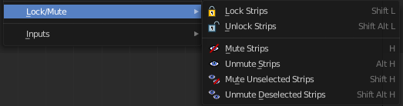
Lock/Mute

Lock Strips
Locks the strip from editing. They can't be moved or edited anymore.

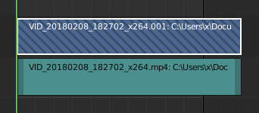
Locked strips appears hatched.

Unlock Strips
Unlock locked strips.

Mute Strips
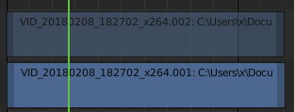
Mutes the selected strips. They do not play anymore, and they appear greyed out.

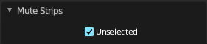
Last operator Mute Strips

Unselected
Mute unselected strips.

Unmute Strips
Unmutes selected muted strip.

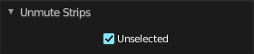
Last operator Unmute Strips

Unselected
Unmute unselected strips.

Mute unselected strips
Mute the unselected strips.

Last operator Mute Strips

Unselected
Mute unselected strips.

Unmute deselected Strips
Unmute all deselected strips.

Last operator Unmute Strips

Unselected
Unmute unselected strips.

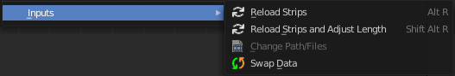
Inputs

Reload Strips
Reloads the strips in the sequencer.

Reload Strips and Adjust Length
Reloads the strips in the sequencer.

Change Paths/Files
Undocumented Operator. Opens a file selector.

Swap Data
Swaps the data between two selected strips. The strips must be compatible.

